OOP Assignment 1

The following classes have been created:
- Address
- Engine
- Car
- Image
- Message
- CarListing
- User (base class)
- Seller
- Buyer
- Admin
Using the following relationships:
- Composition:
- Car HAS-A Engine (Engine belongs to Car)
- CarListing HAS-A Car (Car belongs to Listing)
- Aggregation:
- Seller uses CarListing* (Listing can exist independently)
- Buyer uses CarListing* (Favorites point to external listings)

The following static members:
- - User::totalUsers (counts all registered users)
- - CarListing::totalListings (counts all listings ever created)

And the following constants:
- const int userID (never changes after creation)
- const int listingID (never changes after creation)
- MAX_LISTINGS, MAX_USERS, MAX_FAVORITES, MAX_MESSAGES (global)
- Constant member functions: display(), getFullName(), getSummary() (getters and display functions in general)

CLASS 1: Address
It is a simple class to store location information, used inside Seller and Admin class to show composition
Constructors used:
-Default: when address is unknown
-Parameterized: when full address is provided

CLASS 2: Engine
To store engine details. Composition with Car class.
Constructors used:
- Default: basic 1000cc petrol engine
- Parameterized: specific engine details

CLASS 3: Car
It stores the car details. Contains Engine data member, showing composition, because engine cannot exist without car.
Constructors used:
- Default: for unknown cars
- Parameterized: for full car details
- Copy: to duplicate a car template for a new listing

CLASS 4: Image
it stores a single photo for a car listing.
Constructors used:
- Default: empty image slot
- Parameterized: when uploading a real photo

CLASS 5: Message
For chat messages sent from one user to another (buyer and seller)
Constructors used:
- Default: for empty message
- Parameterized: real message with sender, receiver, content

CLASS 6: CarListing
This is the main listing posted on the marketplace and uses composition of Car and Image array.
* Static member: totalListings (used because it tracks how many listings have been created across the entire program, not just per listing.
* Const member: listingID (because ID doesnt change after creation of listing)
Constructors used:
- Parameterized: a listing always needs a car & seller

CLASS 7: User (Base Class)
This is the parent class of Seller, Buyer, and Admin, demonstrating inheritance and polymorphism.
* Static member: totalUsers (because seller, buyer and admin use the same counter
* Const member: userID (ID doesnt change after creation
Constructors used:
- Default: for blank user
- Parameterized: user with real info

CLASS 8: Seller (inherits User)
For posting car listings, and has a shop name and address. It aggregatesCarListing via pointer array./
Aggregation: Seller stores pointers to listings. (becuase listing should be able to exist even after seller deletion)
Constructors used:
- Default: for blank seller

CLASS 9: Buyer (inherits User)
Can browse, save favorites, and message sellers. The class aggregates CarListing via pointer array (favorites).
Constructors used:
- Default: blank buyer
- Parameterized: buyer with budget and city
CLASS 10: Admin (inherits User)
Can approve or reject listings, and ban users.
Constructors used:
-Parameterized: admins always need credentials

Main Function
In the main function, firstly, we create addresses. Then, we register users. Next, we create engines and cars and listings, using dma. Then we add photos to a listing and send for admin approval. Lastly, buyer saves favorites and contacts seller.

Website screenshots used as reference:
Seller class:


Car class:
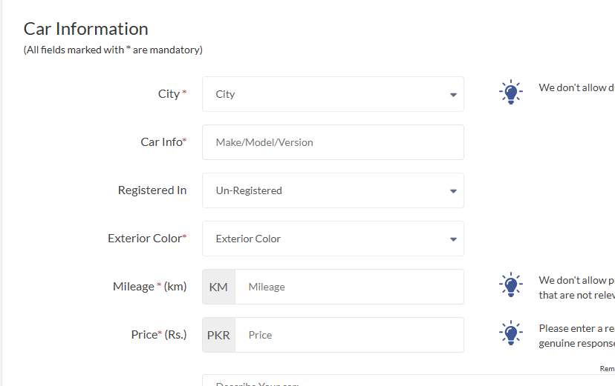
Image class:
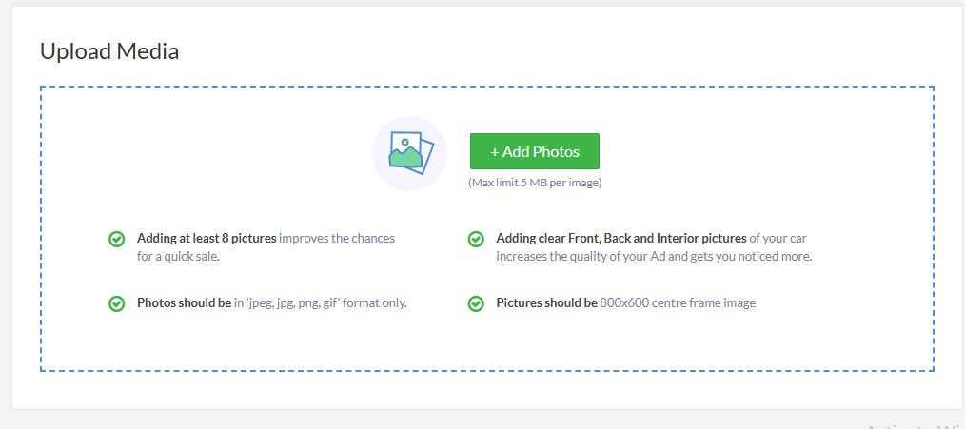
Address class:
